An Analytic Framework for Comparing

Alternative Parameterizations of the Dirichlet-Multinomial Distribution

Jon Brodziak, NOAA Fisheries, Pacific Islands Fisheries Science Center
Jon.Brodziak@NOAA.GOV
13 August 2025

This document outlines the analytical framework for a study to evaluate the Dirichlet-multinomial distribution's effectiveness in fitting composition data within stock assessment models. Specifically, we examine two parameterizations of the Dirichlet-multinomial (DM) distribution, a linear form and a saturated form, and include the standard multinomial distribution for comparison. The multinomial model assumes independent trials with fixed probabilities for each category, which often underrepresents variability in real-world compositional data due to heterogeneity and clustering. In contrast, the DM approach models category probabilities as random draws from a Dirichlet distribution, capturing both overdispersion and inter-category correlation. The objective of the study is to assess which DM parameterization performs best for fitting composition data across a range of stock assessment scenarios.
To facilitate this comparison, we define the notational framework and introduce two DM parameterizations as described by Thorson et al. (2017) and Fisch et al. (2021). The first step is to establish a glossary of key terms and symbols used throughout the study, which describe the data structure and parameter vectors relevant to fitting composition data (Table 1). This standardized terminology enables precise comparison and reproducibility across different likelihood formulations. Our intention is to provide a clear and consistent basis for the statistical modeling approaches employed.
Composition data are counts or proportions of individuals classified into predefined categories—such as age or size classes—capturing the distribution of characteristics within a statistical sampling frame. We will use age-structured data as the type of composition data sampled from the fish stock. The number of categories, or age classes, is denoted by A, with the age bins a=1, 2, …, (A-1) representing true ages and the and the age bin A representing the plus group consisting of all individuals A and older.
Three types of count vectors are used in this study. The vector of actual numbers at age in the stock is . The observed count vector from the sampling frame is with sample size . The predicted count vectors estimated by optimizing the parameters of the multinomial or DM likelihood fitted to the observed data is .

Table 1. Glossary of terms.
Variable | Description
A | Number of categories of age or size bins indexed by a = 1, 2, …, A
 | True population count vector with elements
 | Observed count vector with elements
 | Predicted count vector with elements
 | True population proportion vector with elements
 | Observed proportion vector with elements
 | Predicted proportion vector with elements
 | Observed composition sample size
 | Concentration parameter vector for the Dirichlet-multinomial distribution
 | Sum of concentration parameters for the Dirichlet-multinomial distribution
 | Weighting parameter for the linear Dirichlet-multinomial distribution
 | Weighting parameter for the saturating Dirichlet-multinomial distribution
 | Effective sample size for the observed proportions

Three types of proportion vectors are used in this study. The first is the true population proportion vector at age in the stock is . The observed proportion vector is . The predicted proportion vector estimated from the observed data is . We deterministically simulate the true population proportion vector and sample the population proportion vector with observation error. We then estimate the population proportion vector by optimizing the parameters of the multinomial or DM likelihoods. The simulated population could also include process error due to random fluctuations in demographic factors and environmental conditions. The sampled population will include observation error due to sample size and random variation in observed samples as well as coverage and vulnerability to the sampling gear. The predicted population includes uncertainty due to estimation error and the amount of contrast and variability in the observed data input to the composition likelihoods.
The multinomial distribution models the probabilities of counts across multiple categories when a fixed number of independent trials each result in a single categorical outcome, making it useful for estimating proportions from age composition data. It assumes that each trial is independent, that the category probabilities remain constant across trials, and that outcomes are mutually exclusive, typically requiring a simple random sampling design from a well-defined population. Proportions are estimated by dividing the observed counts by the total number of trials, yielding maximum likelihood estimates of the true category probabilities. The multinomial likelihood for an observed set of counts is
and the multinomial negative loglikelihood for a set of observed composition data is
In equation (1.2) the parameters of the are in the vector of predicted proportions at time t as a function of the input sample size and the observed proportions .
The multinomial negative loglikelihood for composition data sampled in a set of T time periods by a set of V fishing fleets indexed by v is
where the capitalized boldface is a VxTxA-dimensional array and is a TxA-dimensional array with proportion vectors at age in the last dimension. The parameters of the are the 2-D array of predicted proportions at time t as a function of the input sample sizes and the array of observed proportions .
The Dirichlet-multinomial distribution extends the multinomial distribution by allowing the category probabilities to vary according to a Dirichlet distribution, making it suitable for modeling overdispersed count data. Like the multinomial, it models counts across multiple categories from a fixed number of trials, but it assumes that the underlying category probabilities are not fixed but randomly drawn from a Dirichlet prior, reflecting variability across samples or clusters. This distribution accounts for extra variation due to unobserved heterogeneity or correlated observations, such as in cluster sampling, where the assumption of independent trials is violated. Proportions are still estimated from observed counts, but the Dirichlet-multinomial model inflates the variance of those estimates to better reflect real-world sampling variability.
We want to contrast the estimation performance of two alternative forms of the Dirichlet-multinomial distribution used for fitting composition data. The first form is the saturated Dirichlet-multinomial distribution (DMS). The DMS likelihood for an observed set of counts in a single period is
and the saturated Dirichlet-multinomial negative loglikelihood is
where is the saturated Dirichlet-multinomial weighting parameter and the parameters are the vector of predicted proportions and the weighting parameter .
The saturated Dirichlet-multinomial negative loglikelihood for a set of T sampling periods and a set of V fishing fleets is

The parameters of the are the predicted proportions by period and the weighting parameter as a function of and the observed proportions .
The second form is the linear Dirichlet-multinomial negative loglikelihood which is
where is the linear Dirichlet-multinomial weighting parameter.
The linear Dirichlet-multinomial negative loglikelihood for a set of T sampling periods and a set of V fishing fleets is

The parameters of the are the predicted proportions by period and the weighting parameter as a function of and the observed proportions .
References
Fisch, N., Camp, E., Shertzer, K., Ahrens, R. 2021. Assessing likelihoods for fitting composition data within stock assessments, with emphasis on different degrees of process and observation error. Fisheries Research, 243, 106069, https://doi.org/10.1016/j.fishres.2021.106069
Thorson, J.T., Johnson, K.F., Methot, R.D., Taylor, I.G. 2017. Model-based estimates of effective sample size in stock assessment models using the Dirichlet-multinomial distribution. Fisheries Research, 192:84-93, https://doi.org/10.1016/j.fishres.2016.06.005

Appendix
The effective sample size in period t for the saturated Dirichlet Multinomial depends on and
And for a set of periods is
The effective sample size in period t for the linear Dirichlet Multinomial is
And for a set of T periods is
We want to identify any critical points of the two Dirichlet Multinomial forms to help understand the curvature features of the sample size surface. The gradient for the effective sample size of the linear Dirichlet Multinomial is
There is a single critical point for the effective sample size at . The Hessian matrix for the effective sample size of the linear Dirichlet Multinomial evaluated at is
Eigenvalues of H are so is a saddle point for the effective sample size of the linear Dirichlet Multinomial. Here is a plot showing the saddlepoint.
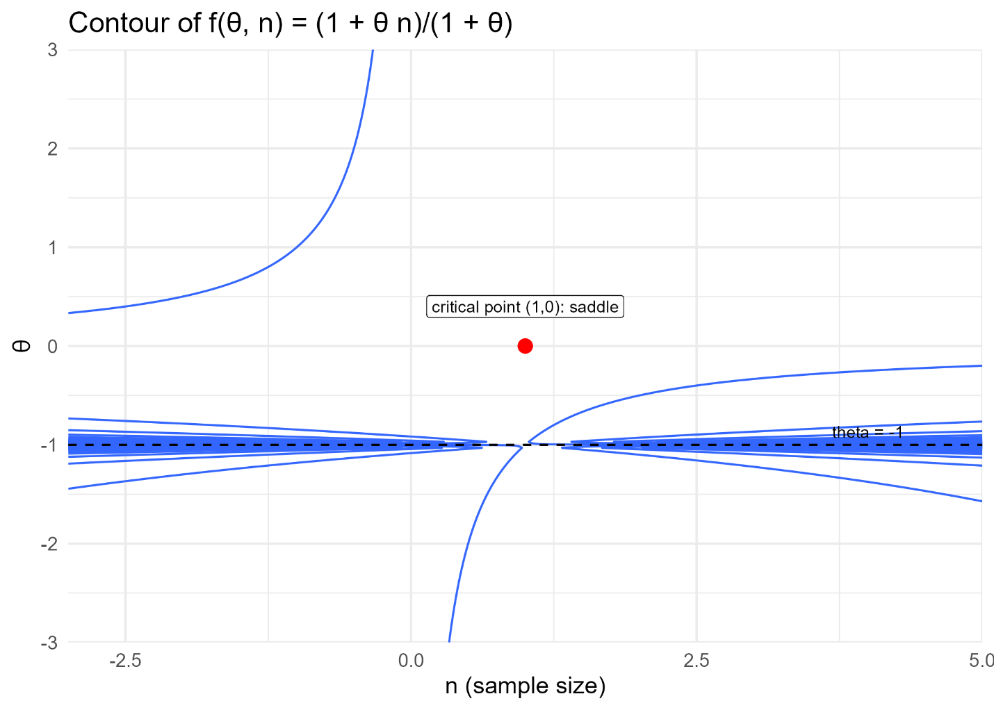
Here is a plot of the gradient vector field for the effective sample size function for the saturated Dirichlet Multinomial.
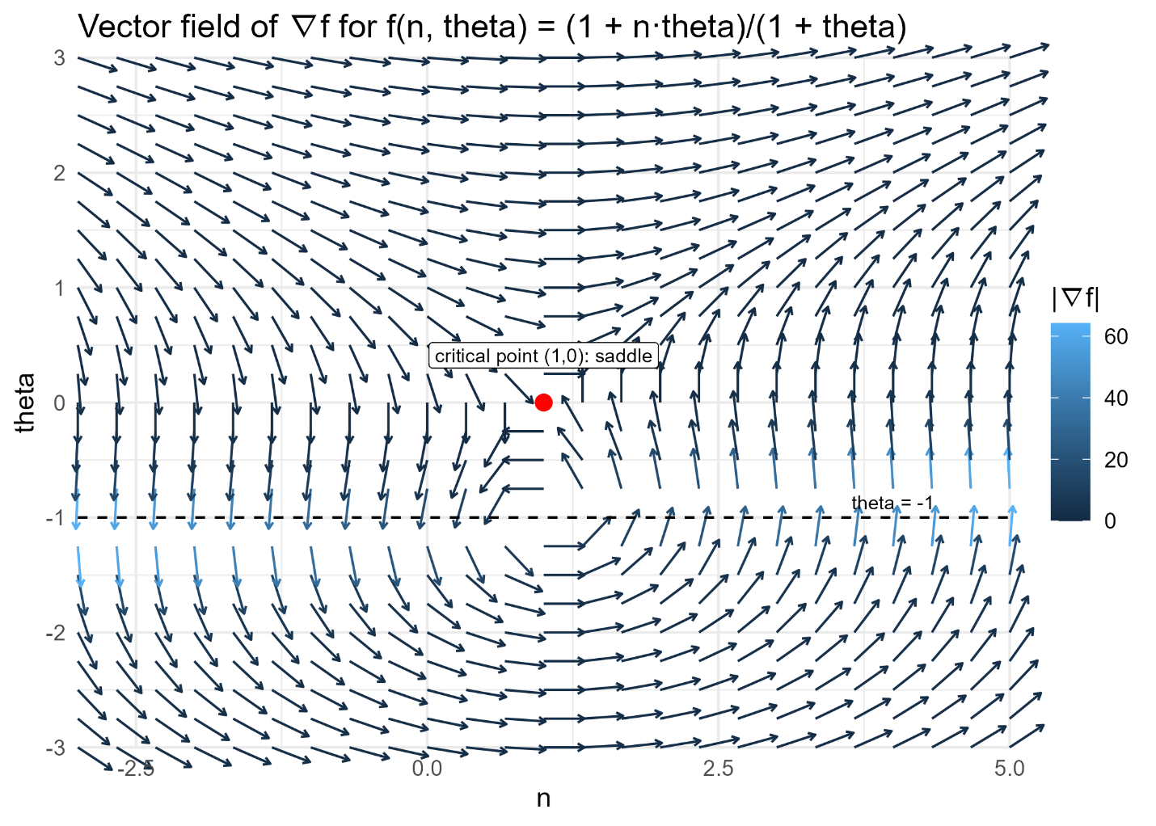
Similarly, the gradient for the effective sample size of the saturated Dirichlet Multinomial is
and the two feasible critical points are .
The Hessian matrix for the effective sample size of the saturated Dirichlet Multinomial is
The Hessians evaluated at the critical points are
Eigenvalues of both Hessians are so both are saddle points for the effective sample size of the saturated Dirichlet Multinomial. Here is a plot showing the saddlepoints.
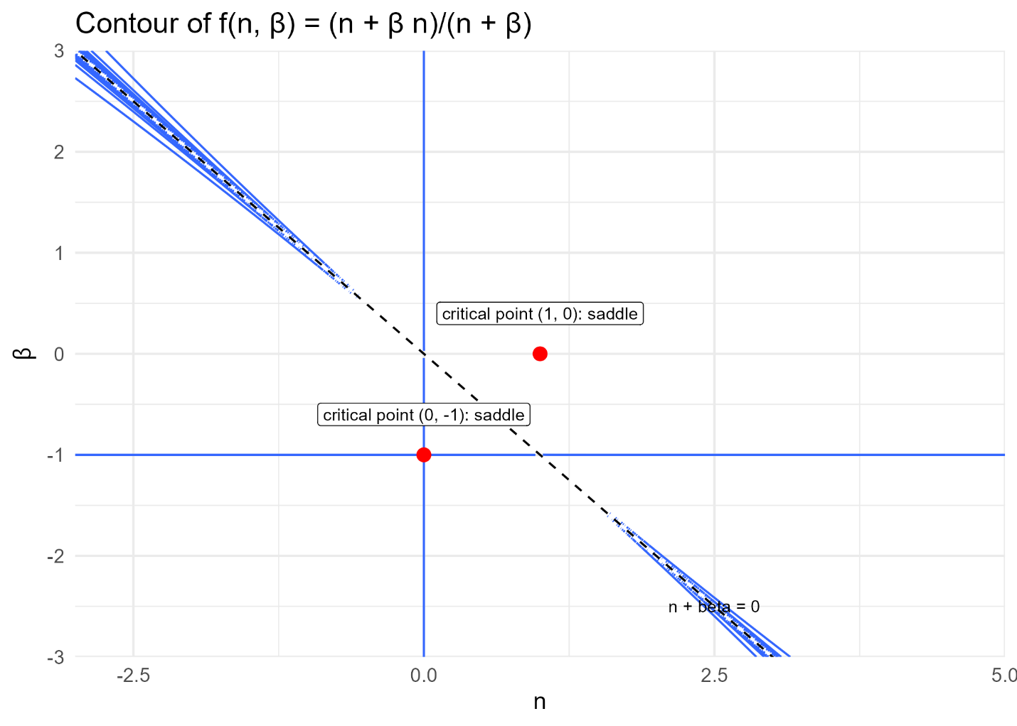

Here is a plot of the gradient vector field for the effective sample size function for the saturate Dirichlet Multinomial.
